Are ewe ready for lambing?

NEW SERVICE!
Pre-Lamb Bums and Bellies

OPTIONAL EXTRAS:
- Vaccinations
- Drenching
- Hoof Trimming

Call us today and get us around before your lambs are on the ground!
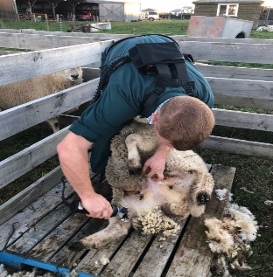
(03) 2159237 and ask for Sam
